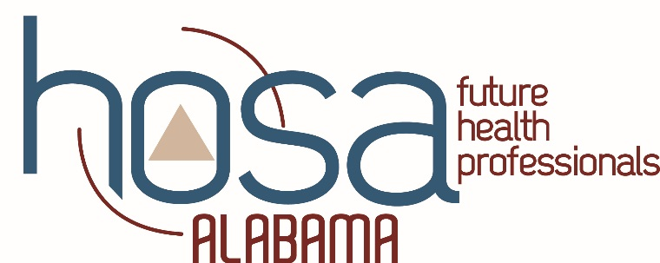

HOSA EXECUTIVE COMMITTEE

2019-2020 REQUIRED MEETING DATES

APRIL 11-12, 2019 EXECUTIVE COUNCIL MEETING

MONTGOMERY (9 am start)

(State officer and Advisor must attend)

JUNE 10-12, 2019 CTE LEADERSHIP SUMMIT

DRURY INN AND SUITES - MONTGOMERY
(State officer and Advisor must attend)

JUNE 17-JUNE 23, 2019 HOSA INTERNATIONAL LEADERSHIP CONFERENCE
ORLANDO, FLORIDA

(State officer and Advisor must attend)

JULY 29-31, 2019 ALACTE SUMMER CONFERENCE
BIRMINGHAM, ALABAMA
(State officers/Advisors must attend 1st day & the day before –
For JLDC planning and officer/advisor meet and greet)

DECEMBER 8-10, 2019 JOINT LEADERSHIP DEVELOPMENT CONFERENCE
BIRMINGHAM (BJCC)

(State officer and Advisor must attend)

JANUARY 23-24, 2020 EXECUTIVE COUNCIL MEETING
MONTGOMERY (9 am start)

(State officer and Advisor must attend)

FEBRUARY TBD, 2020 GOVERNOR’S PHOTO OP & PROCLAMATION SIGNING
MONTGOMERY (1:15 pm – 3:30 pm)
(State officer and Advisor must attend)

FEBRUARY 19-21, 2020 HOSA STATE LEADERSHIP CONFERENCE MONTGOMERY (Actual meeting is 20-21)

(State officer and Advisor must attend)

