2019-2020
ALABAMA HOSA EXECUTIVE COMMITTEE

State Office Address: HOSA Business Office Address:
Alabama Department of Education Alabama HOSA Business Office
Health Science Education/HOSA PO Box 1440
P.O. Box 302101 Owasso, OK 74055
Montgomery, AL 36130-2101 *All Alabama HOSA financial transactions/inquiries
Phone: 334-694-4755 Phone: 334-450-2723
Email: alabama@ctsofinance.org

State Staff:
Dana Stringer, Education Specialist and HOSA State Advisor
Personal Cell: 334-322-4988
E-Mail: dstringer@alsde.edu

Becky Cornelius, Education Specialist and HOSA State Advisor
Personal Cell: 334-429-4034
E-Mail: rcornelius@alsde.edu

Josh Laney, Education Administrator
E-Mail: jlaney@alsde.edu

President | 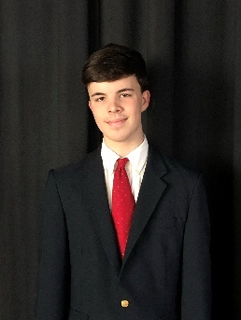 | Jon Ross Folmar  Jfolmar8000@gmail.com | Tabitha Gary  thall@crenshaw-schools.org | Crenshaw County Schools  194 First Avenue  Luverne, AL 36049  334-335-6519  (Crenshaw County)
First Vice President/ Secretary | 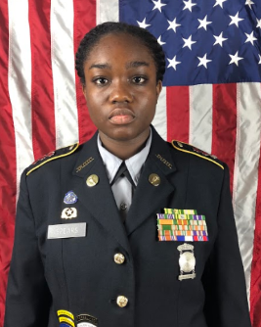 | Lasonya Spears  lasonyaspears@gmail.com | Lee Ann Glass  leeann.glass@hsv-k12.org | Lee/New Century High School  2500 Meridian St.  Huntsville, AL 35811  256-428-8150  (Madison County)
Vice President of Chapter Relations |  | Emmali Osterhoudt  emmaliosterhoudt@yahoo.com | Cindy Quisenberry  cquisenberry@enterpriseschools.net | Enterprise Career & Technical Center  605 West College St.  Enterprise, AL 36330  334-347-2640  (Coffee County)
Vice President of Membership | 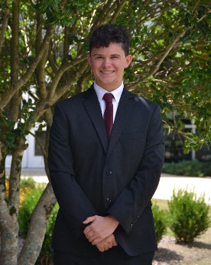 | William Spanier  wspanier02@gmail.com | Melinda Lawson  mlawson@madisoncity.k12.al.us | Bob Jones High School  650 Hughes Road  Madison, Al 35758  256-772-2547  (Madison County)
2019-2020
Alabama HOSA Executive Committee

