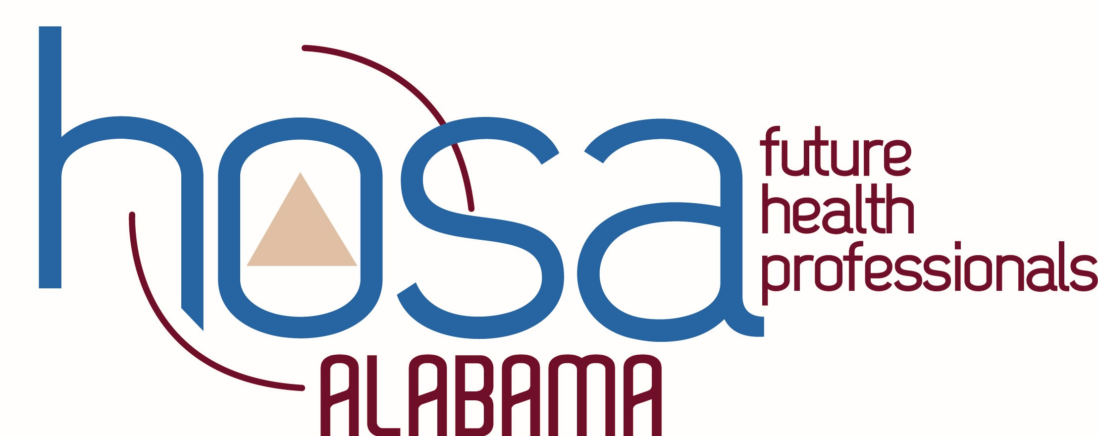
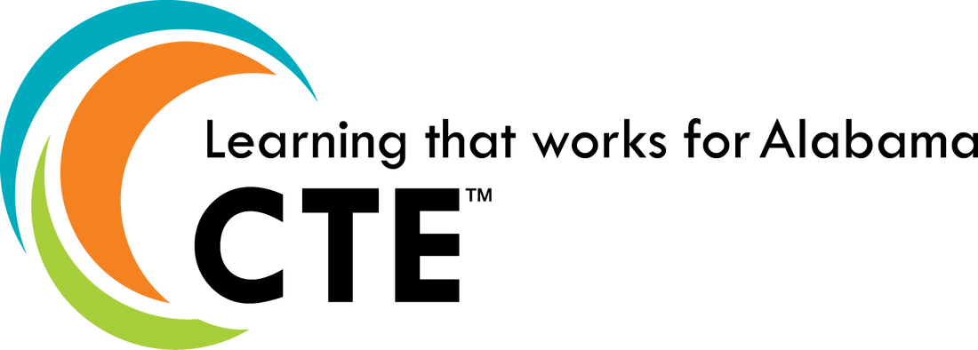
HOSA STATE EXECUTIVE COMMITTEE
PROGRAM OF WORK
2019-2020

GOALS FOR THE STATE ASSOCIATION | PLANS FOR ACHIEVING GOALS | TIME LINE
MEMBERSHIP  - Increase state membership in both active and alumni members. | - State Officers will create letters of information and welcome to secondary and middle school advisors.  - Letters will be emailed to all advisors by the HOSA State Advisor and will be shared through social media by the officers, if appropriate  - Letters will be sent every other month, beginning in August  - Letters will include upcoming events and activities | - August – February
LOCAL CHAPTER PARTICIPATION  - Increase the state’s local chapter participation in HOSA and HOSA related activities. | - State Officers will create a Google Form for Alabama HOSA Advisor or the Quarter.  - Form will be proofed by State Officer Advisors and State HOSA Advisor prior to its release  - Officers will use social media and emails to promote the award  - Officers will use social media to recognize the award winners  - Officers will use social media to promote and recognize local HOSA chapters’ community involvement and HOSA activity participation (i.e. HOSA Week)  - A monthly hashtag will be used to track activity (#ALHOSAStrongSept)  - HOSA week dress up days will be included in this competition  - HOSA Week emphasis. Officers will create a letter to advisors encouraging members to participate in HOSA Week Dress Up Days.  - Advisors will proof letter  - State Advisor will distribute the letter  - Officers will also promote these activities during visits  - Days include: HOSA Spirit Day, NSP Day, Health Profession Day, Disney Day, and Western Day  - Officers will visit local HOSA chapters  - Offers to visit will be made to advisors at Summer Conference  - Small chapters will be targeted through individual contacts and offers of visits and workshops. | - September, November, January  - Monthly, begin in August  - October, November  - August - SLC

COMMUNICATION, INTERACTION, AND PUBLIC RELATIONS  - Increase communication and HOSA awareness through early initiative programs and social media. | - Alabama HOSA will continue to offer the HOSA Spotlight Recognition Event.  - Promotion through social media and advisor emails  - Officers/Advisors will communicate and interact with Alabama HOSA members through social media a minimum of twice every two weeks.  - Officers will host Q&A sessions with HOSA members through Instagram a minimum of every other month.  - Members send in questions and officers reply | - April – SLC  - April – Feb  - May – Feb
INCREASE LEADERSHIP CHARACTERISTICS THROUGH HOSA  - Increase leadership characteristics, chapter effectiveness, and participation in community service. | - Officers will revise and update HOSA workshops  - Information on running for state office will be included in each workshop if requested.  - Officers will provide workshops at JLDC designed to teach leadership characteristics  - Potentially to include: Jon Ross/ Teamwork, Lasonya/Confidence and Self-Awareness, Emmali/Sportsmanship and Modesty, William/Communication  - Officers will attend the CTE Leadership Summit and the ILC State Officer Training  - Officers will develop the finalized plan at that time after the training sessions mentioned above. | - April  - December
EVALUATION (Criteria used to determine to what degree goals will be achieved.)

- State membership will increase by a minimum of 60 active members, or by a minimum of 100 members when including alumni membership.
(2018-19 membership 9,496, Alumni 652)
- Participation in the State HOSA Spotlight event will include a minimum of 10 chapters.
(2018-19 – 8 chapters)
- Participation in the Advisor of the Quarter event will include a minimum of 5 chapters.
(pilot year)
- Participation in the Active HOSA Chapter event will include a minimum of 5 chapters.
(pilot year)
- Officers will make a minimum of 40 chapter visits providing workshops and encouraging participation.
(2018-19, 36 visits)
- Social media engagement will increase in Instagram, Twitter, Facebook, and YouTube
(Emmali to gather current data and provide updates on progress at each meeting)
Social media posts (>2/every other week), Instagram Q&A bimonthly), Advisor Recognition (quarterly), Chapter Participation Recognition (Monthly)

