ALABAMA HOSA

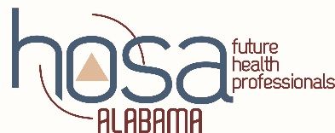
“GIVE ME 10” AND “100%” MEMBERSHIP CAMPAIGN APPLICATION FORM FOR RECOGNITION

APPLICATIONS MUST BE EMAILED BY JANUARY 8TH

Use this form to document that your chapter has increased HOSA membership by 10
members for the academic year and/or to document your Health Science program has 100% HOSA membership. This application must be submitted electronically to the state office by JANUARY 8TH, 2020

PLEASE PROVIDE THE FOLLOWING INFORMATION

Name of Chapter

School Name

School Address

City/Zip

School Phone Advisor’s E-mail

Advisor’s Name(s)

(If more than one advisor, list all names)

Previous Year’s Chapter Membership

Present Year’s Chapter Membership

We have met one of the following requirements. (Place an X in the appropriate boxes below)

YES | NO

We affiliated* ten more HOSA members than last year.
We affiliated* as a new HOSA chapter (that did not affiliate last year) with at least 10 members.
We have 100% membership (All CURRENT Health Science students are paid HOSA members):

_______ Total number of students enrolled in the Health Science program

Total number of HOSA members

*Affiliated means the dues and membership affiliation form for HOSA chapter has been received at national headquarters. Dues must be received in the national office and this application form must be sent ELECTRONICALLY to the state office by January 8th to qualify for recognition.

By typing my name below, I certify the above information in this application is correct.

Chapter President ____________________________ Date _________
(Signature)

Chapter Advisor _____________________________ Date _________
(Signature)

Send application and copy of HOSA affiliation form by January 8th to:
Becky Cornelius, HOSA State Advisor alabamahosa@alsde.edu

State Approved _____________________________ Date _________

