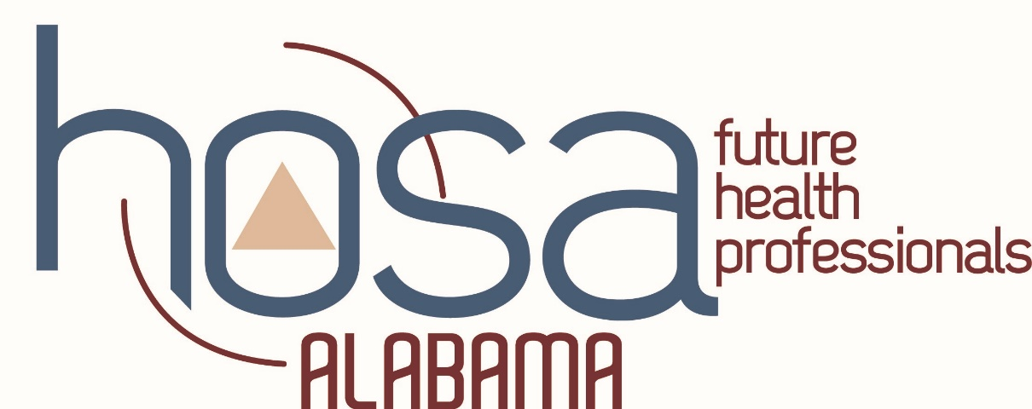

HOSA IMPORTANT DATES

HOSA SAM Conference | September 22-26 | Dana & Becky receive HOSA updates
HOSA WEEK | November 3-9
SQE Registration Deadline | November 15 | (Payment postmark date is 7 days after registration closes)
Pin Design Submission Deadline | November 15
-SQE payment postmarked date  -JLDC registration deadline | November 22
State Qualifying Events Window | December 1 – 7 | Tests and TALLO submissions due
State Officer App Deadline | December 7th
State Officer Candidate Testing | Dec 12th -13th  (NEW) | State Officer Exam only given during this time frame.  Candidates who submitted completed applications will be registered for the exam by State Advisor
SQE Results Released | Dec 15th | Posted to website: www.alabamahosa.org
JLDC | December 9-10 | Leadership training for members
SLC Registration Deadline | January 8 | No late registrations  (Payment postmark date is 7 days after registration)
Scholarship Application Deadline | January 8
Other Recognition Events Application Deadline | January 8 | Advisor/Member/Outstanding HOSA State Leader of Year  HOSA Spotlight/ Give me 10/100% membership/ HOSA Happenings
SLC payment postmarked date | January 15
TALLO Submission Deadline for SLC | February 7th
State Leadership Conference | February 20-21
Top Six scorers will be posted to webpage | March 9 | 3 per event will be invited to compete at ILC
International Leadership Conference intent forms due | March 23 | Every top six winner must complete
Champ Camp | April 8th | Preparation for ILC
ILC Registration Deadline | May 8
ILC | June 24-27 | ILC Houston, TX
REVISED 12/20/19

