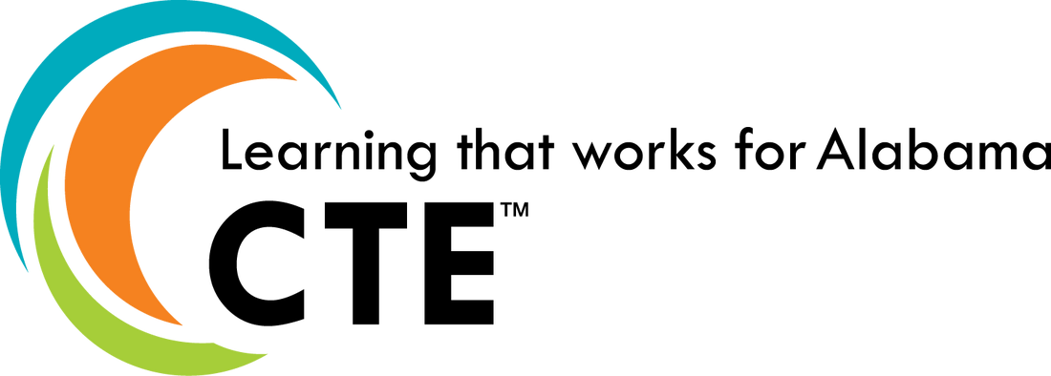
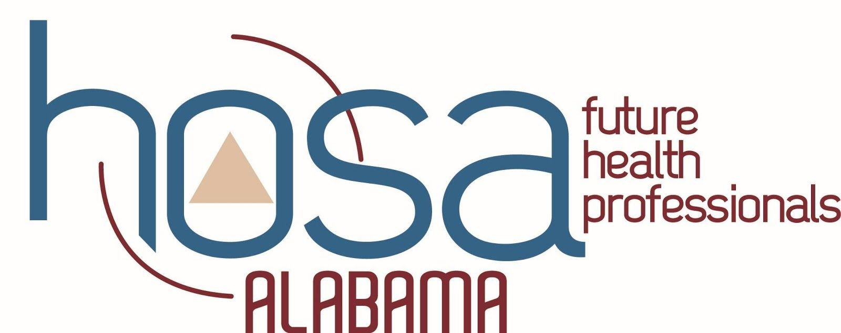
HOSA STATE EXECUTIVE COMMITTEE PROGRAM OF WORK
2020-2021

GOALS FOR THE STATE ASSOCIATION | PLANS FOR ACHIEVING GOALS | TIMELINE
MEMBERSHIP | - State Officers will create letters of information and welcome to postsecondary, secondary, and middle school advisors.  - Letters will be created to encompass all levels of HOSA classification in order to raise efficiency. They will include upcoming events, activities, and outstanding chapter recognitions.  - Letters will be emailed to all advisors by the HOSA State Advisor and will be shared through social media by the officers, if appropriate  - Letters for postsecondary members will be emailed directly to them.  - Letters will be sent every month, beginning in September  - State Officers will create letters of information to alumni members.  - Letters will be emailed to all alumni members by the HOSA State Advisor.  - Letters will be sent in June and December.  - Letters will include updates, upcoming events, and opportunities available to alumni members.  - State Officers will emphasize the formation of relationships between all HOSA chapters within their communities.  - State Officers will create monthly activities for chapters to do with middle school groups that will be shared through social media and newsletters.  - State Officers will encourage high school chapters to recognize postsecondary members that were past secondary participants.
 |  | 1. | September – March
1. Increase state membership in both active and alumni members.
 |  | 2. | June, December
 |  | 3. | Monthly, begin in September

LOCAL CHAPTER PARTICIPATION | - State Officers will create a Google Form for Alabama HOSA Outstanding Advisor  - Form will be proofed by State Officer Advisors and State HOSA Advisor prior to its release  - Officers will use social media and emails to promote the award  - Officers will use social media to recognize the award winners  - Officers will use social media to promote and recognize local HOSA chapters’ community involvement and HOSA activity participation (i.e. HOSA Week)  - A monthly hashtag will be used to track activity (#ALHOSAStrongSept)  - HOSA week dress up days will be included in this competition  - HOSA Week emphasis. Officers will create a letter to advisors encouraging members to participate in HOSA Week Dress Up Days.  - Advisors will proof letter  - State Advisor will distribute the letter  - Officers will also promote these activities during visits  - Officers will also promote these activities through social media. Chapters participating in the activities will be featured on social media pages.  - Days include: HOSA Spirit Day (Mon), Health Professions Day (Tues), Superhero Day (Wed), NSP Day (Thurs) and Beach Day ( Fri).  - Officers will visit local HOSA chapters  - Offers to visit advisors at Summer Conference  - All chapters will be targeted through individual contacts and offers of visits and workshops. | 1. | December
1. Increase the state’s local chapter participation in HOSA and HOSA related activities. |  | 2. | Monthly, begin in August
 |  | 3. | October, November
 |  | 4. | September - SLC

COMMUNICATION, INTERACTION, AND PUBLIC RELATIONS  1. Increase communication and HOSA awareness through social media. |  | - Alabama HOSA will continue to offer the HOSA Spotlight Recognition Event.  - Promotion through social media, advisor emails, and letters.  - Officers/Advisors will communicate and interact with Alabama HOSA members through social media a minimum of twice weekly.  - Officers will create YouTube videos showcasing major events for HOSA members.  - Compilations of activities and events will be showcased after the event has finished.  - YouTube videos will be shared through social media and newsletters.  - Officers will host Q&A sessions with HOSA members through Instagram a minimum of every month.  - Themes for Q&A sessions will be decided a month beforehand.  - Members send in questions and officers reply.  - Officers will also prepare questions that they anticipate will be asked. | 1. | May – SLC
 |  |  | 2. | May – Feb
 |  |  | 3. | ILC, JLDC, SLC
 |  |  | 4. | June - Feb
INCREASE LEADERSHIP |  | - Officers will revise and update HOSA workshops  - Information on running for state office will be included in each workshop if requested.  - Adjustments for middle school chapters will be included in each workshop as needed.  - State Officers will emphasize in their visits for secondary members to become postsecondary and alumni members.  - Officers will provide workshops at JLDC designed to teach leadership characteristics  - Officers will attend the CTE Leadership Summit and the ILC State Officer Training  - Officers will develop the finalized plan at that time after the training sessions mentioned above.
CHARACTERISTICS THROUGH |  |  | 1. | May
HOSA
1. | Increase leadership
characteristics, chapter |  |  | 2. | December
effectiveness, and participation in
community service.
EVALUATION (Criteria used to determine to what degree goals will be achieved.)
1. State membership will increase to a minimum of 10,000 members.
(2018-19 membership 9,496, Alumni 652) (2019-2020 membership as of 5/28/20 9,959; 952 alumni)

2. JLDC attendance will increase by 20 HOSA members. (2019 attendance- 505)
3. Middle School membership will increase by a minimum of 50 members.
4. Participation in the State HOSA Spotlight event will include a minimum of 10 chapters. (2018-19 – 8 chapters) (2019-2020- 5 chapters)
5. Officers will make a minimum of 40 chapter visits providing workshops and encouraging participation. (2018-19, 36 visits) (2019-2020- 32 visits)
6. Social media engagement will increase in Instagram, Twitter, Facebook, and YouTube
(Madison to gather current data and provide updates on progress at each meeting)
Social media posts (>2/every week), Instagram Q&A (monthly) Youtube Videos (after major events)

