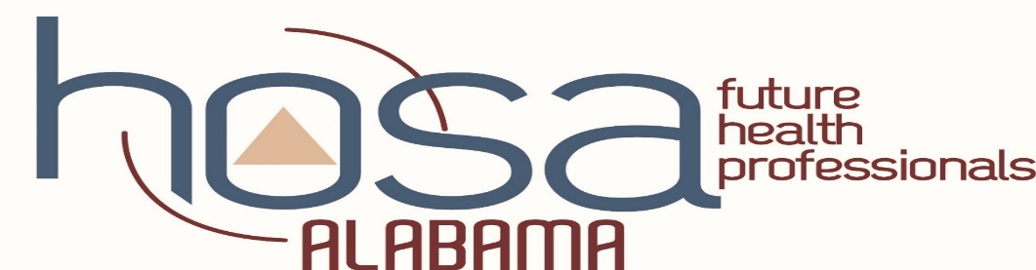

HOSA IMPORTANT DATES 2020-21
HOSA SAM Conference | September 2020  TBA | Dana & Becky receive HOSA updates
HOSA WEEK | November 1st -7th
SQE Registration Deadline | November 6th | (Payment postmark date is 7 days after registration closes)
SQE payment postmarked date | November 13th
Pin Design Submission Deadline | November 16th
JLDC Registration | TBA
State Qualifying Events  Online Submission Window  NEW TIMING FOR THIS YEAR | November 16th | TALLO/WUFOO submissions due for SQE  TALLO- SECONDARY & POST-SECONDARY  WUFOO- MIDDLE SCHOOL
State Qualifying Events  TESTING WINDOW | December 1st–7th | Testing events test online including state officer exam
State Officer App Deadline | December 7th
JLDC | December 7-8th | Leadership training for members
SQE Results Released | Dec 15th | Posted to website: www.alabamahosa.org
SLC Registration Deadline | January 11th | No late registrations  (Payment postmark date is 5 days after registration)
Scholarship Application Deadline | January 11th
Other Recognition Events Application Deadline | January 11th | Advisor/Member/Outstanding HOSA State Leader  HOSA Spotlight/ Give me 10/100% membership/ HOSA Happenings
SLC payment postmarked date | January 16th
TALLO Submission Deadline for SLC | February 18th | Updates from SQE submissions if required/ Banner Submissions Due
State Leadership Conference | March 4th & 5th
Top Six scorers from SLC will be posted to webpage | March 12th | 3 per event will be invited to compete at ILC
International Leadership Conference intent forms due | March 23rd | Every top six winner must complete
Champ Camp | (TBD) | Preparation for ILC
ILC Registration Deadline | TBD | Online registration, payment postmarked, & ILC forms email deadline!!
ILC | June 23-26, 2021 | International Leadership Conference- Orlando, FL
Revised 7/21/20

